Dear Cognizant Artificial Intelligence virtual experience program team

I have completed Task 1. Exploratory Data Analysis

The finding is like this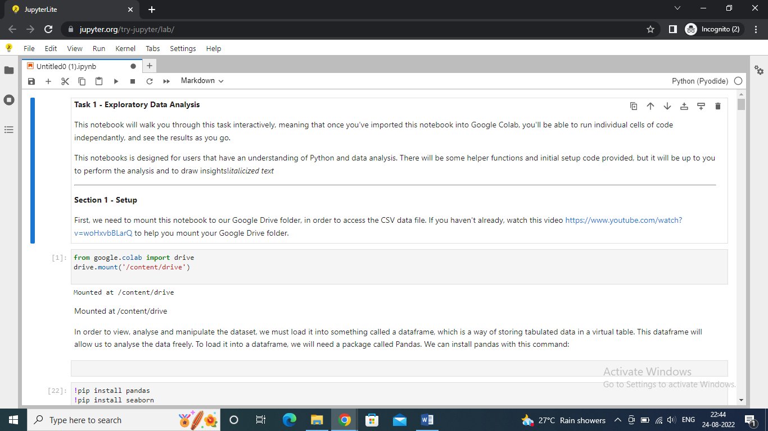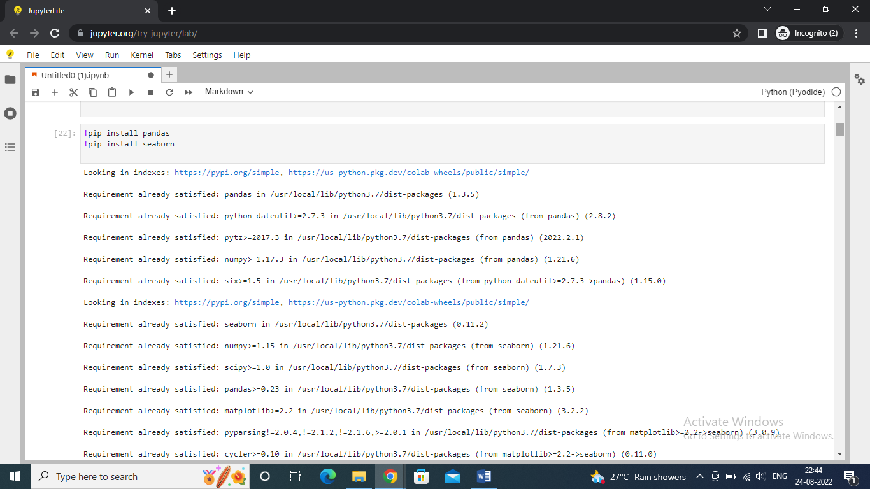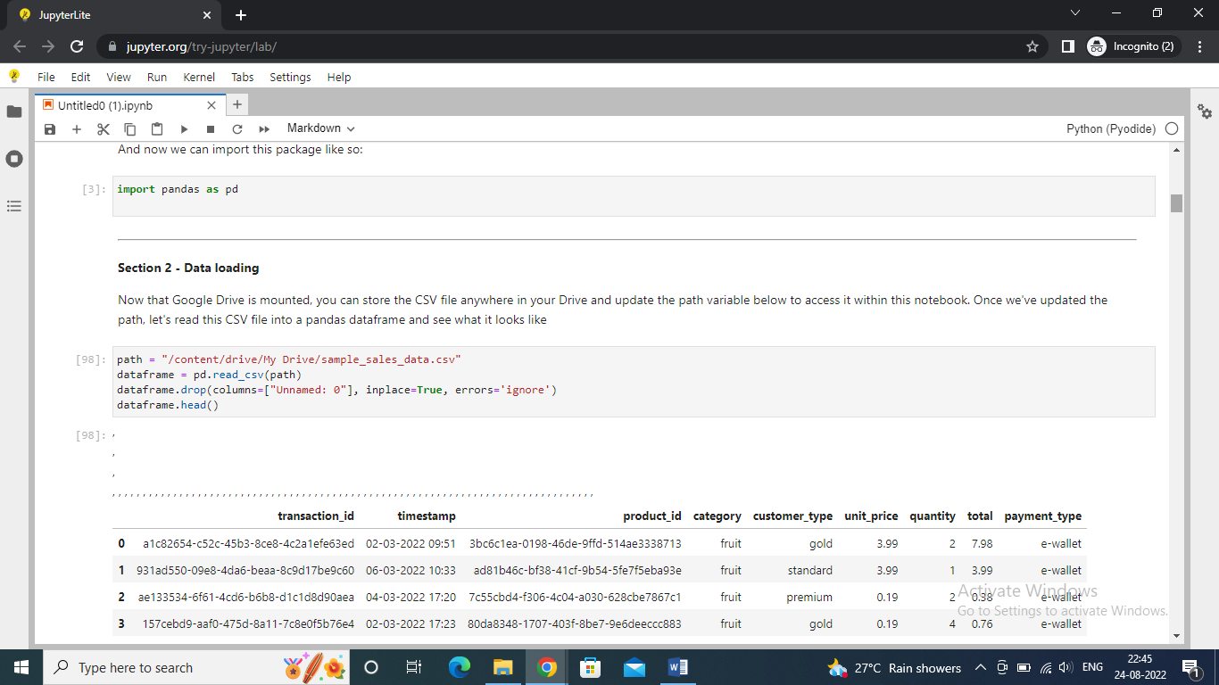

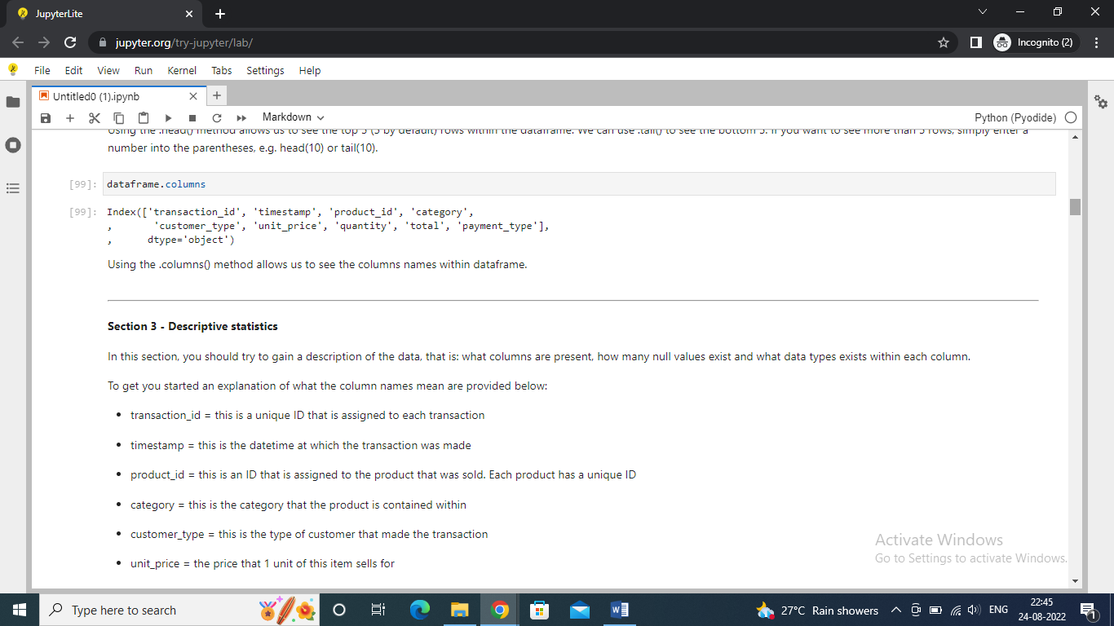

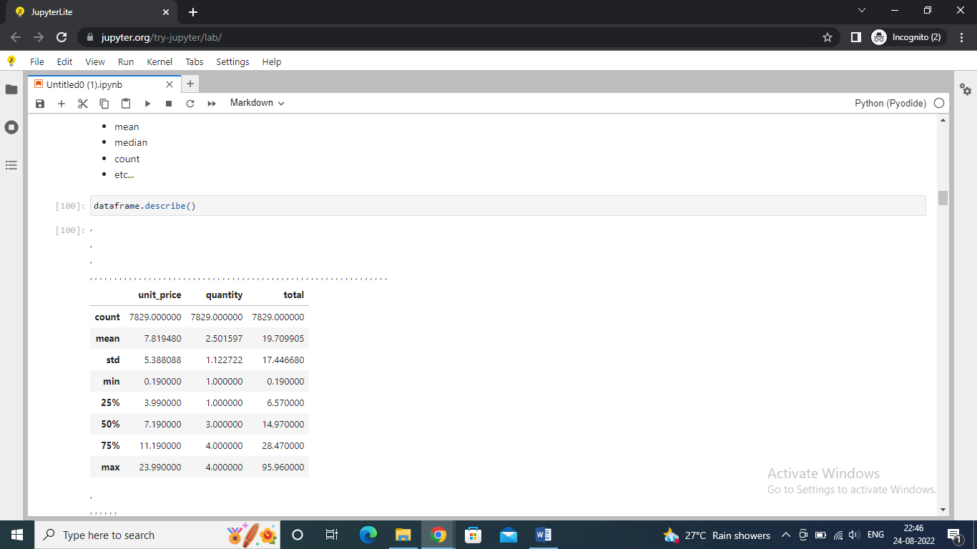

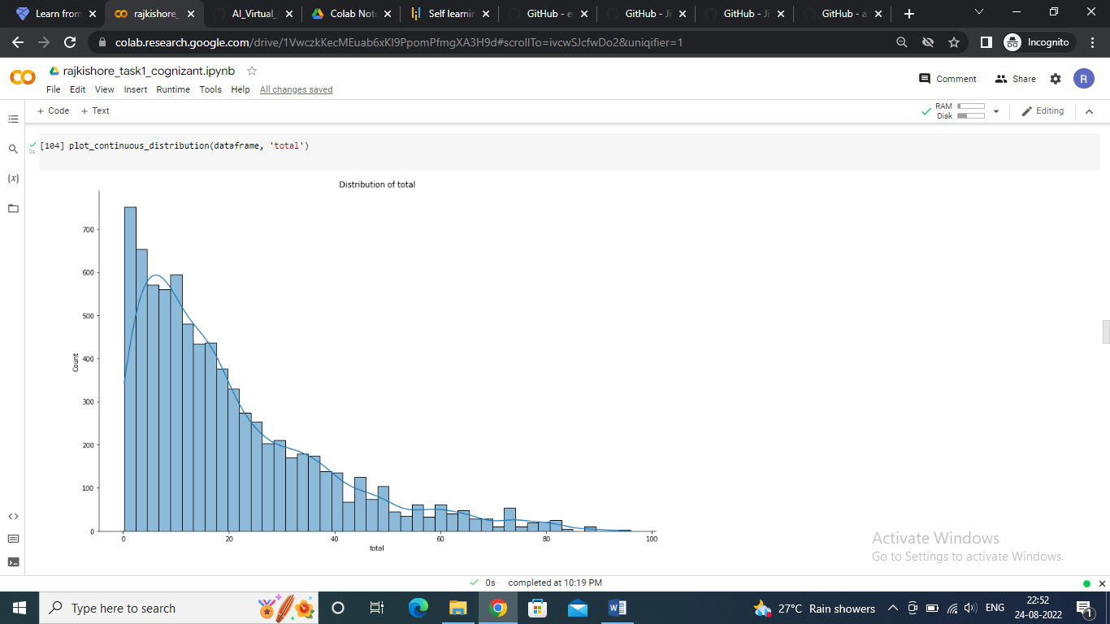

Rest of file can be found at this link- <https://colab.research.google.com/drive/1VwczkKecMEuab6xKI9PpomPfmgXA3H9d?usp=sharing>

this is a great course and great task to practice skills

Best regards,

Rajkishore Lal